
11 ATAR Human Biology

Task 11:
DNA and Protein
Synthesis Test

Weighting 6%

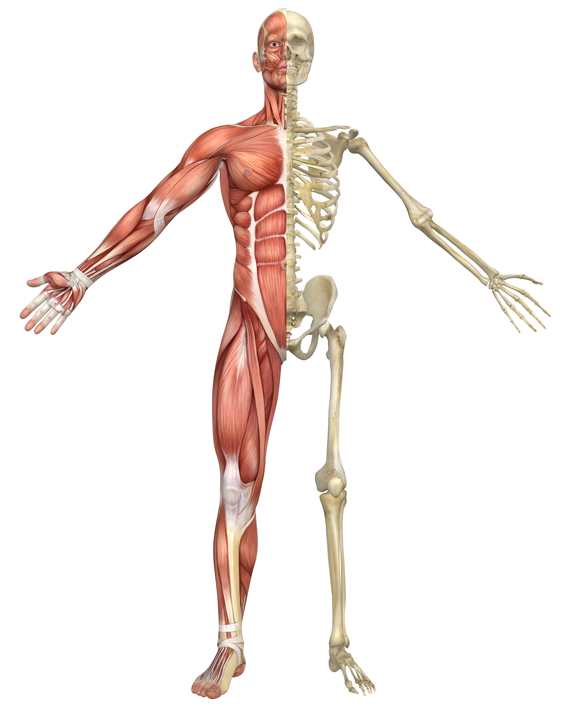

Multiple Choice: 20 marks
Short Answer: 40 marks
Extended Answer: 10 marks
TOTAL 70 MARKS

Section A: Multiple Choice (20 Marks)
Answer all questions by placing and X through the most correct answer on the multiple choice answer sheet.

1.

Use the picture below to fill in the missing parts

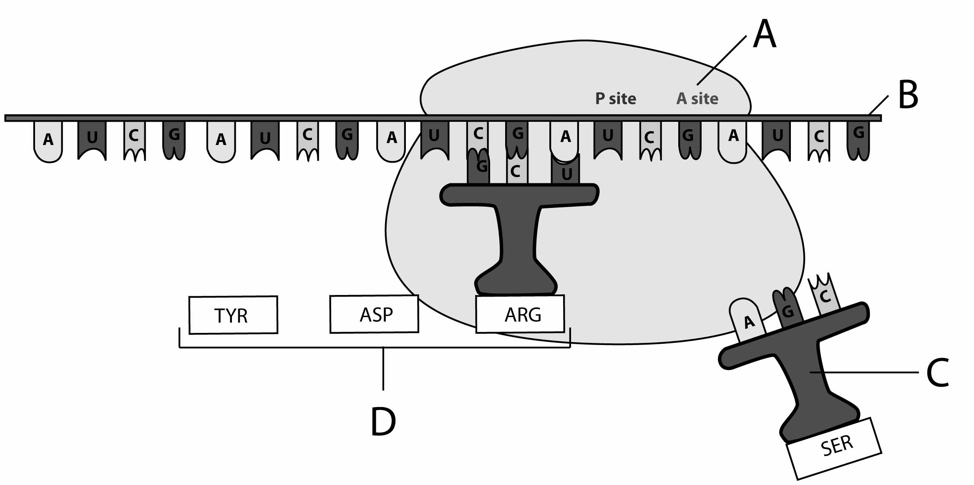

1. A, B C and D respectively are:

- mRNA, tRNA, proteins, ribosome.
- Ribosome, tRNA, mRNA, proteins
- Ribosome, mRNA, tRNA, proteins.
- Ribosome, proteins, mRNA, tRNA

2. Fill in the labels for A and B to show expression of DNA

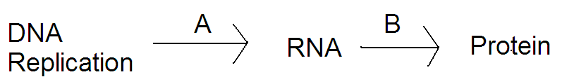

- A= junk DNA, B= amino acid.
- A=DNA, B=translocation.
- A=transcription B=translation.
- A=translation, B=transcription.

In questions 6 and 7 below, a segment of DNA has one strand with the following sequence of bases. A G C G C A T A G C A A

3. The complementary strand of DNA is

a) T C G C C G A T C G T T
b) T C G C G T A T C G T T
c) T C G C A T T A C A U U
d) T C G W R O N G A C U U

4. The mRNA molecule coded for by the original

a) T C G C G T A T C G T T
b) U C G C G U A U C G U U
c) U A C A T T U C A G G G
d) U C G G C A T T U G G C

The next TWO questions refer to the diagrams below that show two parts of a process occurring inside a cell.

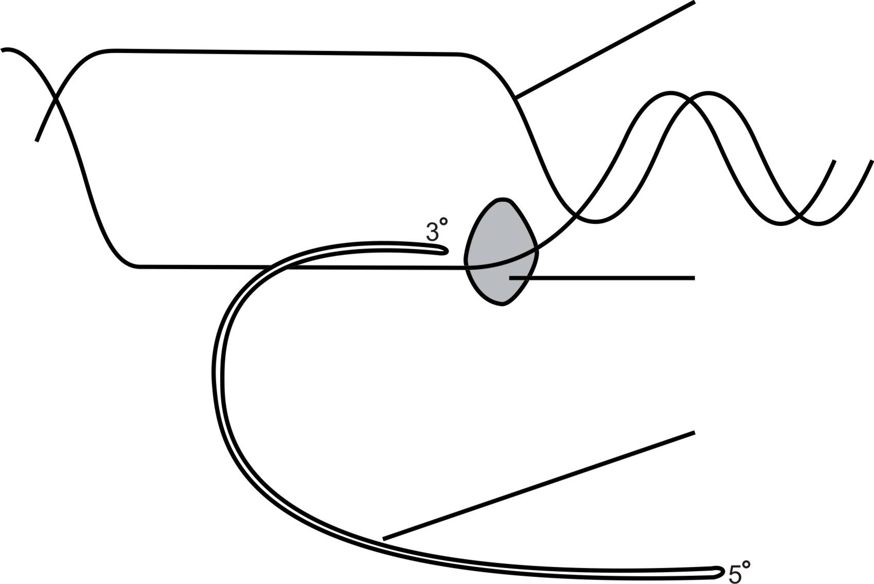
E
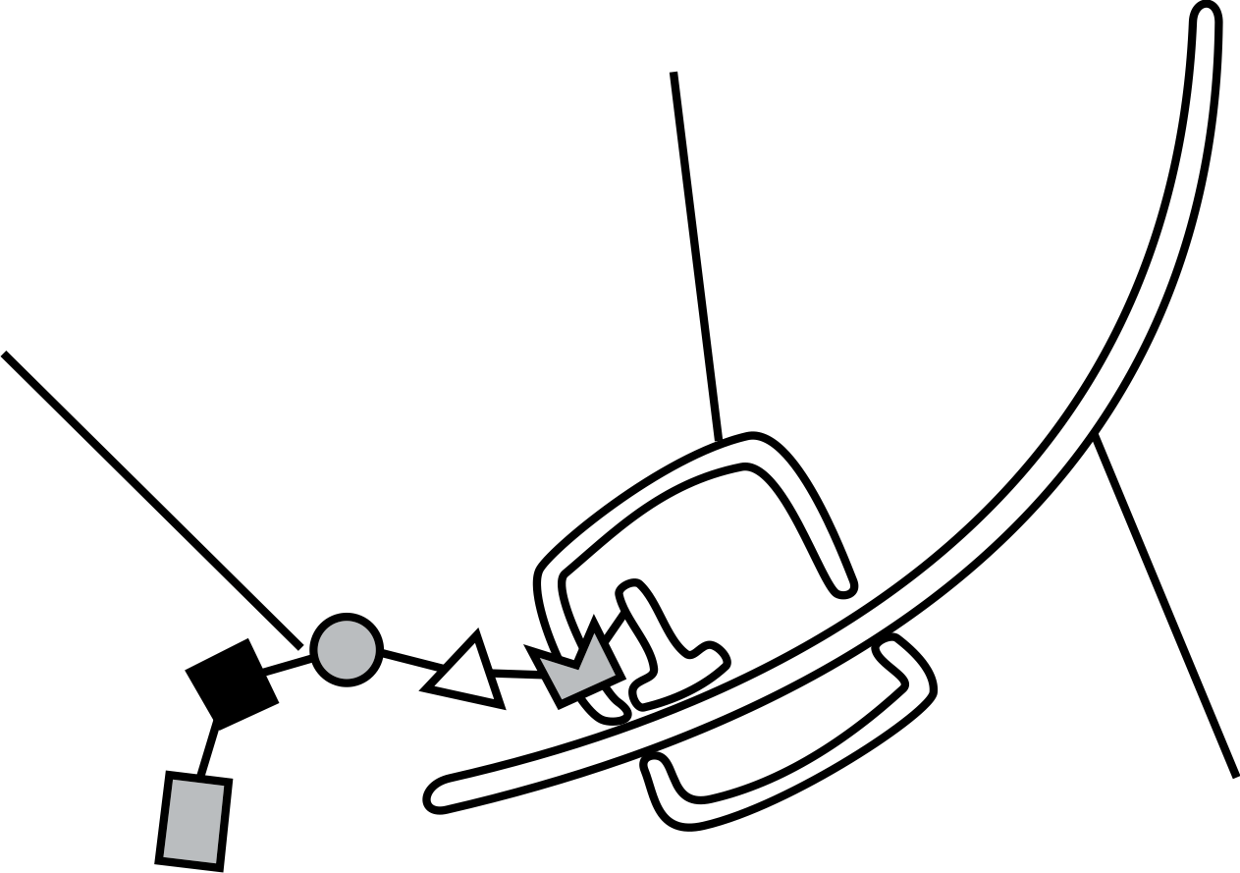
C

D
G

F

F

Stage A Stage B

5. Which of the following statements about the process, indicated in the diagrams above, is correct?

a) Stage A is transcription as the mRNA is being converted to DNA.
b) Stage B is translation and occurs inside the nucleus.
c) Structure C is the ribosome where tRNA is formed.
d) Structure D is the polypeptide chain formed from amino acids.

6. Structure E and structure F are different because structure F

a) contains thymine not uracil.
b) is double stranded not single stranded.
c) is constructed from deoxyribose sugars not ribose sugars.
d) leaves the nucleus, unlike structure E.

The next two questions refer to the following diagram

13.

Refer

The next question refers to the diagram of the cross section of compact bone below:

END OF MULTIPLE CHOICE
11 ATAR Human Biology

Test 3:
and DNA

Weighting 6%

NAME:_____________________________

DATE:______________________________

Section A: Multiple choice (20 Marks)
Answer all questions by placing and X through the most correct answer on the multiple choice answer sheet.

1. a b c d 11. a b c d
2. a b c d 12. a b c d
3. a b c d 13. a b c d
4. a b c d 14. a b c d
5. a b c d 15. a b c d
6. a b c d 16. a b c d
7. a b c d 17. a b c d
8. a b c d 18. a b c d
9. a b c d 19. a b c d
10. a b c d 20. a b c d
Section B – Short Answer (38 marks)
Answer all questions in the spaces provided.

1. (5 marks)

(4 marks)

2. (4 marks)
T
(2 marks)

3. The diagram shows how DNA is used to code for specific amino acids (2 marks)
which join to make a particular protein

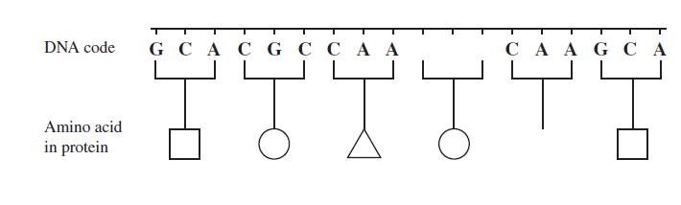
Complete the diagram by
a) adding the missing sequence of bases on the picture provided (1 mark)

b) drawing the symbol for the missing amino acid. (1 mark)

4. Refer to the diagram to answer the following questions. (5 marks)

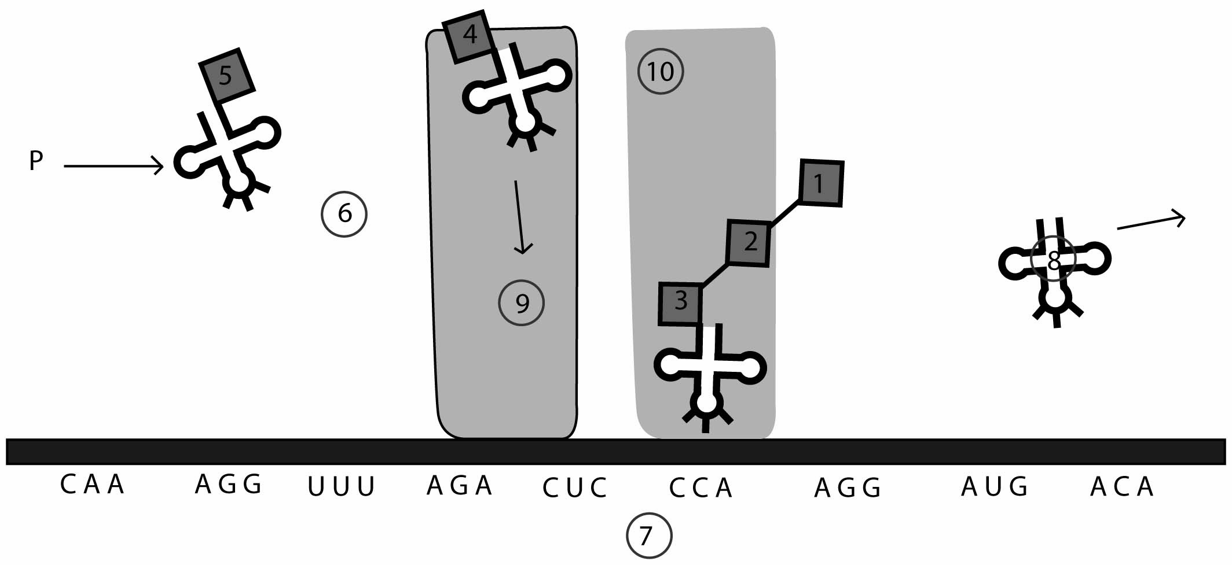
Source picture created by Clinton Ellard

a) Name the following parts:
i. structure 8 ____________________

ii. structure 7 __________________

iii. structure 5 ___________________
(3 marks)

b) What is the codon for amino acid 3 in this chain?

(1 mark)

5. Name and Describe the three categories of joints found in the body (6 marks)

Section C Extended Answer (10 Marks)
Answer the following question in the space provided.
DO NOT WRITE ANSWERS IN PENCIL. Write your answers on lined pages with each question CLEARLY LABELLED.

Protein synthesis involves two stages, transcription and translation. Describe the main
steps in each of these processes (10 Marks)

